Chapter 19, Solution 53.

For the z parameters,
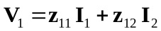 (1)
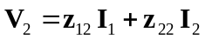 (2)

For ABCD parameters,
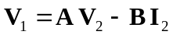 (3)
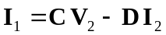 (4)

From (4),
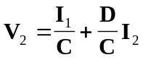 (5)

Comparing (2) and (5),
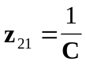, 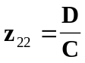

Substituting (5) into (3),
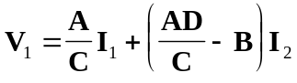
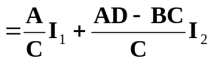 (6)

Comparing (6) and (1),
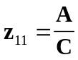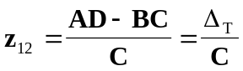

Thus,
[Z] = 